Signature dishes
Main Courses

Herb topped Roast Chicken Supreme £13
Corn, Leg & Barley risotto, asparagus, butter chicken sauce

Cod loin £16
Red pepper pipperade, char-grilled Aubergine & Courgette,
Smoked Mussels, split Basil cream

Lamb Rump £17
Braised Neck fritter, Provencal vegetables, Samphire, jus

Stonebass fillet £14
Herb crushed potatoes, baby gem, Peas, Asparagus, tartar sauce

Starters

Twice Baked Cheddar & Spring onion Soufflé £6
Parmesan cream

Spiced Morecambe Bay Shrimps £7.50
Pikelet, micro herb salad

Potted Salmon £7
Gin Cured Salmon, sourdough crisp, pickled vegetables

Confit tomato & Buffalo mozzarella tart £6.50
Basil, Rocket, Aged Balsamic

Stonebaked Pizzas

Tomato, Mozzarella, Basil £9

Prosciutto, Pepperoni, Chicken, Chorizo £12

Roasted Red pepper, Red onion, Courgette & Aubergine £10

Chicken, Red Peppers, Prosciutto, BBQ Sauce £12

Four Cheese & Chive £11
(Mozzarella, Cheddar, Goats Cheese, Blue Cheese)

Caramelised Red onion, goats cheese, Rocket £11

Pancetta, Chorizo, Red Peppers, VERY HOT SPICY BASE £12
(extremely hot, hottest in the area)

Additional Toppings £1.50

Calzone
Chicken, Roast Med veg, Garlic Butter, Basil pesto £12

Roast Med veg, Goats cheese, Basil pesto £10

Garlic Butter Pizza £7

Garlic Butter & Mozzarella Pizza £8

Comfort Classics

Soup of the day £6
Homemade soup, farmhouse bread

Chicken Kiev £13
Minted new potatoes, Butter greens

Slow braised Lamb Shank £17
Champ mash, buttered green beans, rosemary gravy

Smoked Haddock & Spring onion fishcake £13
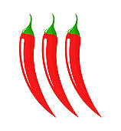
Wilted spinach, lemon Beure Blanc

Caesar Salad £10 (with chicken £13)
Anchovies, Parmesan, Caesar dressing

Wild mushroom & spring onion Linguini £12
Parmesan shavings, watercress - (have it with Chicken - £15)

Beer battered Haddock fillet £13
Hand cut chunky chips, mushy peas, tartar sauce

Roast Red Onion and Goats Cheese tart £12
Shallot and Rocket salad, Red wine reduction

Twice Baked Cauliflower Cheese Soufflé £11
Green Salad

From the Char Grill

Our steaks are all dry aged for a minimum of 28 days and cooked on a Char-grill £19
Served with thrice cooked chips – grilled tomato – flat cap mushroom – watercress salad
8 oz Sirloin ¦ 8oz Rib Ribeye
Sauces – Peppercorn – Blue Cheese – Garlic Butter – Red wine Jus £4.00

Aspect Burger £12 (Vegi-burger - £11)
Pancetta, cheddar, gem, tomato, gherkin, red cabbage slaw, thrice cooked chips

Side dishes - £4each
Green vegetables ¦ Hand cut thrice cooked chips
house salad ¦ Roasted New Potatoes ¦ Bread Basket

We understand that children are growing people and are happy to provide the same excellent meals but with smaller portions on request.
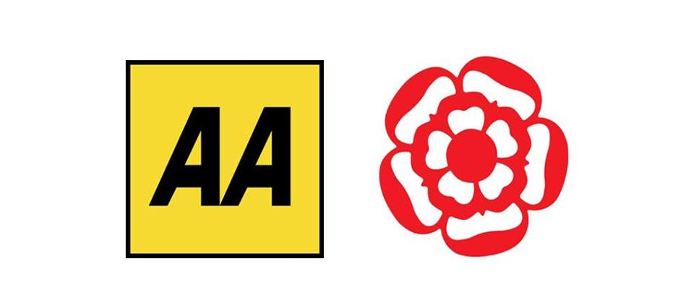
Food Allergies and Intolerances: Before you order your food and drinks please speak to our staff if you have any allergies or intolerances and are unsure about ingredients in our dishes. All of our dishes are made from the freshest locally sourced ingredients. During busy times there may be a short delay. We only serve good food, not rushed food.

